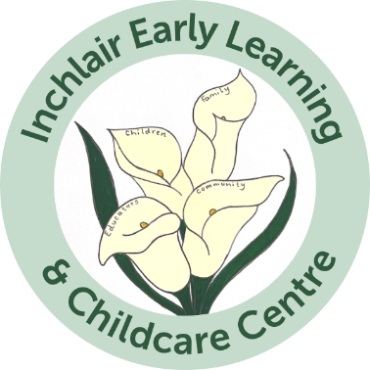

Marvellous Mealtimes Policy

August 2026

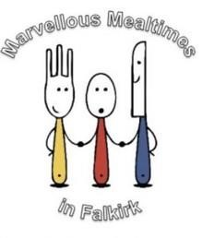

Background
Marvellous Mealtimes is Falkirk’s approach to holistic snack and mealtime experiences, considering the 1,140 expansion. We propose that marvellous mealtimes:
- Ensures all children can enjoy unhurried snack and mealtimes in as relaxed an atmosphere as possible. (Health and Care Standards, 2017, 1.35)
- Provides rich opportunities to foster children’s social wellbeing.
- Are regarded as a rich learning opportunity and we expect that skilled staff plan carefully for these experiences.
- Play a key role in intervening early with young children and families in fostering a healthier relationship with food.
- All children will have suitable meals prepared for them e.g. allergies/dietary requirements.
- Children have a choice of milk or water with meals. Water is always available throughout the day.

Values
We know from experience that marvellous mealtimes will look different across our authority, depending on the context of the setting. However, we have developed marvellous mealtimes values and have worked with practitioners to embed these into each marvellous mealtime approach, so that children are able to experience marvellous mealtimes to its highest quality.
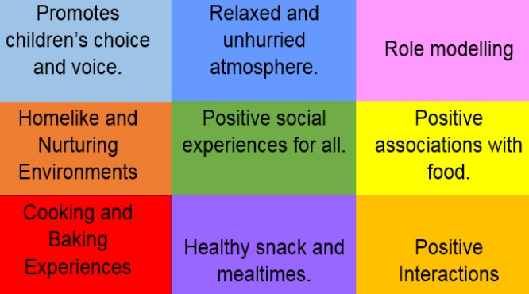

Experiences
All children within your setting should have the opportunity to access a variety of fresh fruit and vegetables, nutritious snack and meals and fresh water and milk on a daily basis.
As a team you must take the time as a team to think about key times for their children in terms of marvellous mealtimes:
- Breakfast is usually available as children arrive in ELC. You’ll usually find that once children are in and settled, baking and cooking experiences begin and take place over the morning.
- Lunch is usually open from 11.30am- 1pm, depending on your hot holding times and food routes. Lunch should:
  - Allow for children to choose when they would like to eat.
  - Enable children to take the time they need to eat, developing healthy eating habits and developing an awareness of when they are hungry and what they need.
  - Allow for children to choose who they would like to experience lunch with.
  - Enable children to self-serve and choose which foods to eat.
  - Allow children to experience lunch with familiar adults and experience high quality interactions from adults who role model.
  - Have time built into the lunch time core time that enables children to relax and reset.

Spaces
Setting the Table (2018, pg.81) states “The environment where children eat can have an impact on positive eating experiences. A quiet, peaceful area with appropriate tables, chairs, cutlery, and crockery, serving opportunities, and the number of staff available at mealtimes are all important factors in providing a positive experience for children. Planning and managing mealtimes, therefore, should also consider the space and set-up for eating as well as the food that is provided.” Consideration should therefore be given to ensure spaces:
- Are warm, comforting, and homelike.
- Are spacious and allow for children to move freely.
- Are familiar and welcoming.
- Are free from clutter and unnecessary resources, furniture.
- Showcase a sense of belonging, e.g., family photographs.

The Larder
We believe that snack and mealtimes are a core part of a child’s learning day and we are keen to improve this further with the notion of a larder.
- Two of the key factors of the larder initiative are:
- Children can self-select from a range of healthy options at lunchtime and snack time.
- Children will play a key role in deciding menus and in the preparation of foods that are served for lunch and snacks.
All Falkirk Council establishments have been automatically registered with the “Scottish Milk and Healthy Snack Scheme”.
- Funds in three payment blocks will be made into your School/Setting Fund bank account.
- Each setting will receive 26.6p per child/day, as follows:
- Snack element of the Scottish Milk and Healthy Snack Scheme (SMHSS) @ 16.6p per child/day
- Larder supplement @ 10p per child/day
The Larder enables settings to ensure that baking and cooking experiences become a part of core provision experiences. Settings must ensure that baking and cooking experiences take place at least twice, if not daily, over the week.
The Larder can also be used to provide children with other options over the lunch time period, which they have helped to prepare themselves, for example a salad bar.
Children should be involved in the planning, shopping, preparation and serving of snacks and meals. This is an integral part of marvellous mealtimes.

Cooksafe and Food Hygiene
CookSafe is a HACCP (Hazard Analysis and Critical Control Point) based system, which Falkirk Council has adopted for ELC settings as their chosen food safety management system. “The main aim of the system is to focus on critical points in the operation and take measures to ensure that problems do not occur”. (CookSafe Food Safety Assurance System, Food Standards Scotland, Issue 1.2, May 2012 Introduction).
It is important to note that when any new member of staff commences employment within your setting they should receive on the job training on the CookSafe procedures appropriate to the level at which they will be working at point of induction and before they take part in any food related work, to ensure that they fully understand the settings ‘house rules’, personal hygiene and cleaning protocols for setting; as well as the relevant charts documentation used by the setting relating to the process steps.
Hygiene awareness instructions should include:
- Micro-organisms and the potential to cause illness
- Personal Hygiene & Health – the need for high standards and reporting of illness
- Effective handwashing
- Cross contamination causes and control
- Allergen Awareness
- The procedures for reporting problems and taking corrective actions
- How to complete records / HACCP charts satisfactorily.
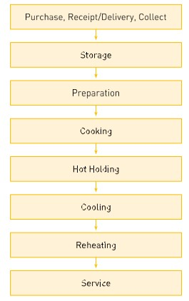
Process Steps include the following:
(CookSafe Food Safety Assurance System, Food Standards Scotland,
Issue 1.2, May 2012 Introduction).

It is important that staff are aware of the 3 main hazards which relate to food safety, and the various stages which they may present during food preparation through to consumption stage, they are as follows:
- Microbiological hazards
- Chemical hazards
- Physical hazards
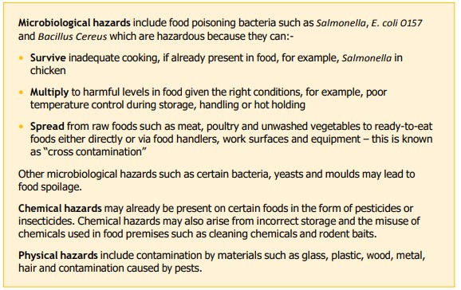
(CookSafe Food Safety Assurance System, Food Standards Scotland, Issue 1.2, May 2012 Introduction).
As with any hazard it is important that control measures are identified and put in place, ensuring that all staff are aware of these e.g. coloured chopping boards, correct storage in fridges, freezers, and cupboards.
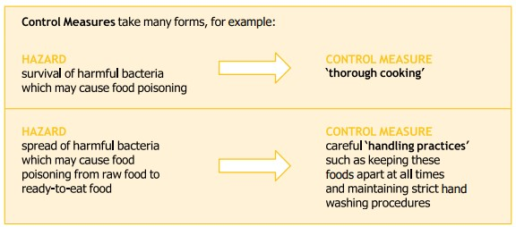
(CookSafe Food Safety Assurance System, Food Standards Scotland, Issue 1.2, May 2012 Introduction).
As with all protocols within settings, monitoring is vitally important to ensure that identified control measures are maintained. This can take various forms from supervising staff carrying out certain procedures to ensuring the correct documentation records are maintained; for example temperature checks on fridges are carried out and recorded on relevant chart, and where they have been identified as not working effectively the appropriate measures – corrective actions are taken and recorded also.
Allergens – What is an Allergen?
A food allergy is when the body’s immune system reacts unusually to specific foods, the food which the body reacts to is known as the allergen and in some very serious cases the reactions to food can be fatal. It is therefore vitally important that the correct protocols are in place to ensure that all food and drinks being provided are safe. To do this we need to be aware of the allergies and intolerances that children and adults may have so that they are not given the foods which will make them ill, identification of ingredients contained within food and drinks to enable the production of safe food within the setting.
Information will be gathered from parents / carers /staff at point of admissions, and documented where staff can access information easily (please see appendix 1: medically prescribed diets referral form), but please be aware that this does not mean that a child or adult within the setting will not take a reaction to a food or drink whilst in your care for the very first time. Vigilance during mealtimes is crucial here, should the reaction be severe, and they go into anaphylactic shock staff must know what to do.
Anaphylaxis - Illnesses & conditions | NHS inform
There are 14 major allergens, and these are shown in the image below.
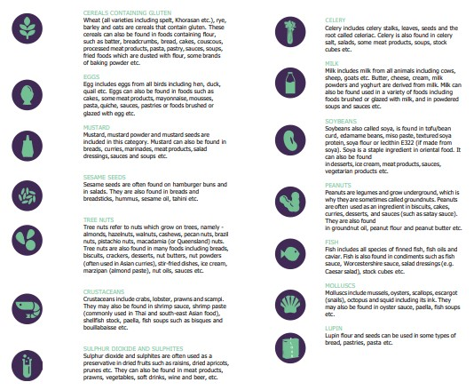
(CookSafe Food Safety Assurance System, Food Standards Scotland, Issue 1.2, May 2012, page 93).
There are different ways which settings can manage allergen risks, from checking the labels of all the products delivered / received for ingredient lists, checking to make sure that no damage has occurred to the packaging which can result in cross contamination, using standard recipes which ensures the food produced is essentially the same all the time. Storage and preparation of foods always need to be considered to prevent any risk of cross contamination, cleaning and hygiene are also key here at all stages as allergen residues can remain which can affect allergen sufferers (See Appendix 2: Allergen Management House Rules and Appendix 3: Allergen Management House Rules Recipe template). Staff training is crucial in relation to allergens and how to respond to any reaction, links below provide free training which can be accessed by all staff.
Online Allergy Training | Food Standards Scotland
Login to MenuCal | MenuCal | FSS
HACCP records need to be retained for an appropriate period to demonstrate that the system is working effectively, and this forms part of the verification process and any actions taken as a result of this process must also be recorded, this role is assigned to the specific member of staff responsible for overseeing the CookSafe – food safety management system.
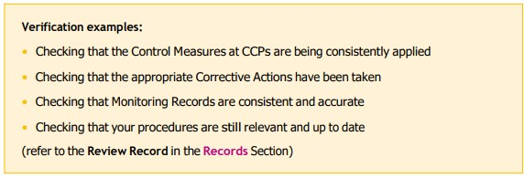
(CookSafe Food Safety Assurance System, Food Standards Scotland, Issue 1.2, May 2012 Introduction).
On an annual basis, all staff should receive training to refresh their knowledge and understanding of the food management system in place and the importance of completing the relevant HACCP charts correctly. This training should be recorded within the individuals training record, located within the CookSafe manual/folder. If concerns have been identified with the practice and implementation of protocols by an individual, then more frequent monitoring and / or reviews may be carried out to ensure that their practice and knowledge is brought back up to the required standard.
The house rules should be reviewed and updated accordingly, this is normally carried out on an annual (or in some cases 6 monthly) basis in Falkirk Council settings – in August at the start of the new academic term, and where an update requires changes to be made out with this period, this may be the case for example if changes are made to the guidance, environment. It is good practice to involve those who are involved in using and implementing the food management system to review the house rules, so that all perspectives are considered.
Please Note: During any inspections, you may be asked to produce evidence of your CookSafe - food safety management system (including archived charts where data is collated to show that system is effective).
Elementary Food Hygiene training

Care & support in relation to choking
What is choking?
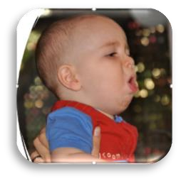
Choking occurs when a foreign object lodges in the throat or windpipe, blocking the flow of air.

Children can be:
- unable to vocalise
- quiet or silent cough
- unable to breathe
- cyanosis
- decreasing level of consciousness

In group settings, mealtimes should be well managed and young children and babies should always be supervised when eating. It is important that staff breaks are managed to make sure children have suitable support while eating. Any risks should be identified and minimised and staff should be suitably trained to promote positive mealtime experiences and supervise children. Managers must make sure that staff are putting any learning and training into practice to promote safe, happy and healthy mealtimes, adhering to the Care Inspectorate guidance prevention and management of choking. In the event of a child choking First Aid Procedures must be followed, recorded and reported.

All Choking episodes are classed as an emergency. An incident form should be filled out detailing what steps were taken and by whom, it should then be signed by staff and the parents. As a reportable incident this should also be recorded on the Care Inspectorate website.
Good practice guidance prevention and management of choking episodes in babies and children.pdf (careinspectorate.com)

Support for Practitioners
Practitioners can access a variety of materials which will support you in the development and improvement of the Marvellous Mealtimes approach in your setting. Access these materials on our Falkirk Early Learning Glow page here.
You can contact Gemma Paterson; Lead Early Years Pedagogue for more information or to discuss the approach in your setting.

Appendix 1: Medically Prescribed Diets Referral Form
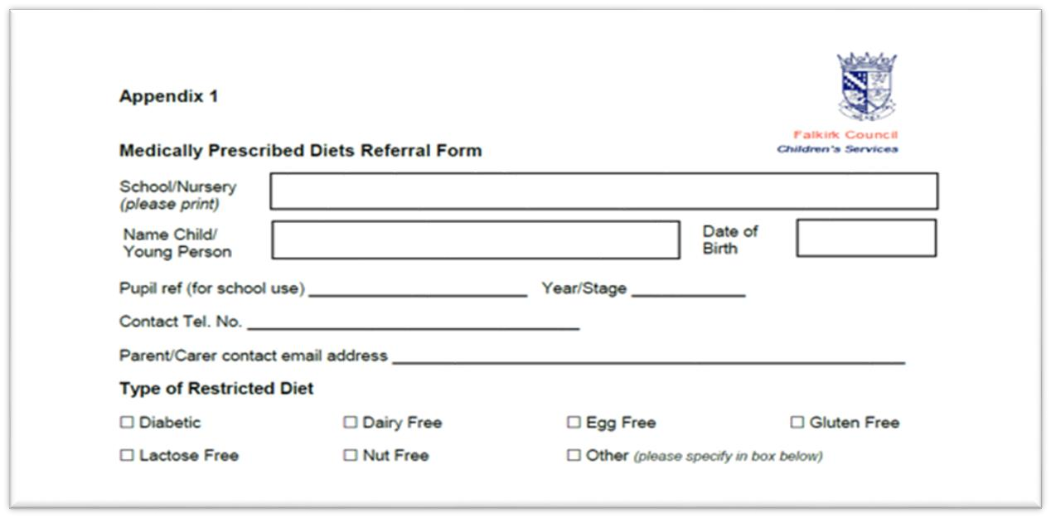

Appendix 2: Allergen Management House Rules
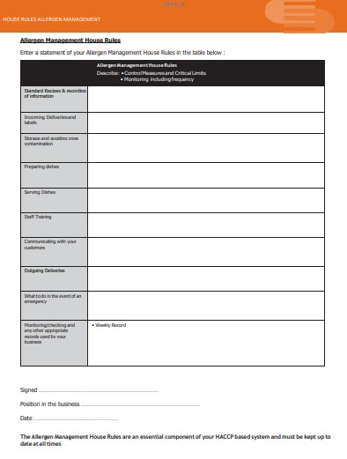
Appendix 3: Allergen Management House Rules Recipe template
